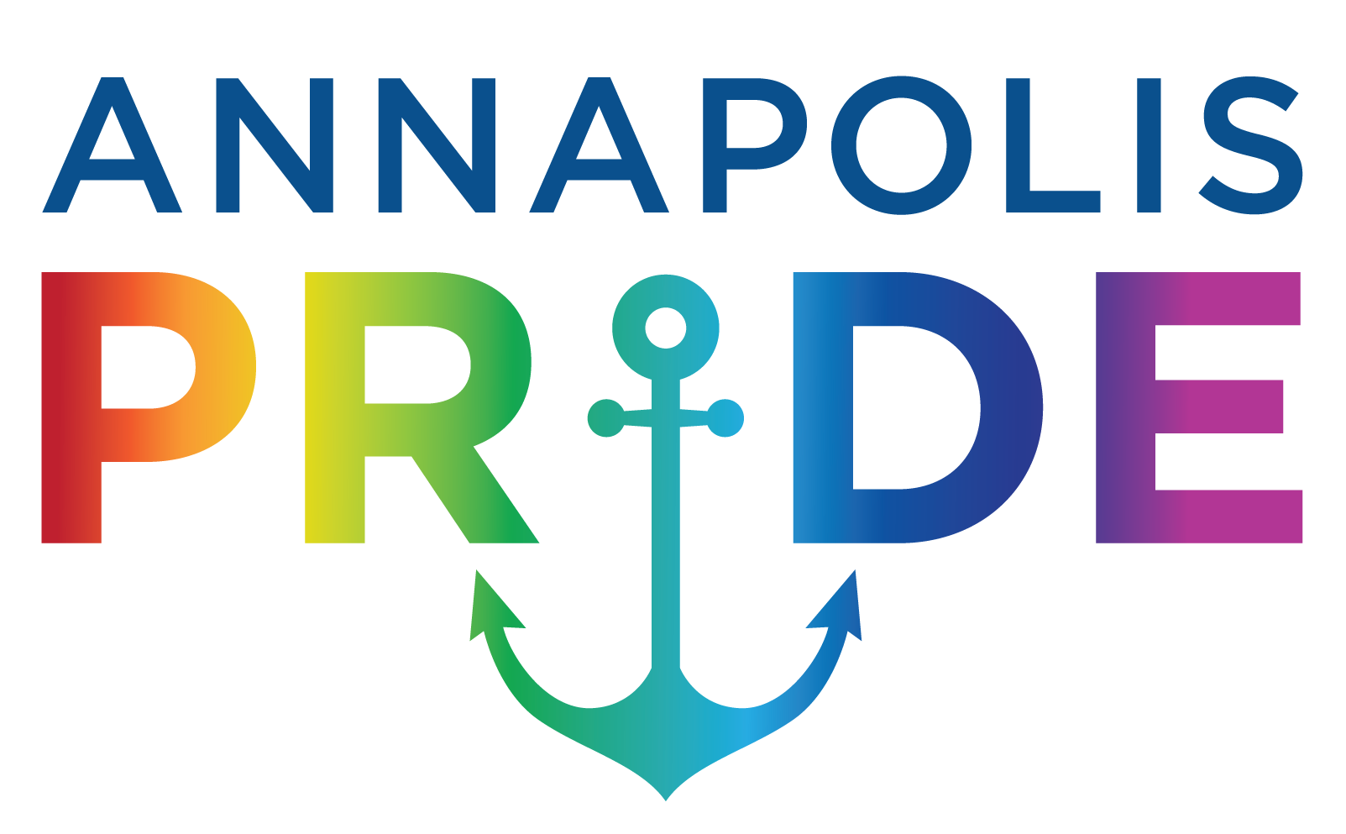
ANNAPOLIS PRIDE BOARD OF DIRECTORS
EXPRESSION OF INTEREST

Annapolis Pride is a community-based 501(c)(3) non-profit organization whose mission is to celebrate the LGBTQ+ community, engage local residents, businesses and groups to unite in welcoming and embracing diversity in Annapolis. We seek to create a safe and welcoming community, increase visibility and awareness, while serving as a clearinghouse for LGBTQ+ activities, services, and organizations. A committed volunteer Board of Directors governs Annapolis Pride. We are always looking for individuals interested in Board service. If you are interested, please complete and submit the form below. A member of the Board will follow up to learn more about you, your skills and experience, and how they can contribute to our vibrant and talented Board of Directors.

First and Last Name:
Email Address:
Phone:
Address:
City, State, Zip:

- What educational certifications, work or volunteer experiences do you have relevant to Annapolis Pride?

- Have you ever served on another Board of Directors?
Yes
No
If Yes, what organization?

- Board members of Annapolis Pride have strategic and fiduciary responsibilities over the organization. In addition, Board members serve in various other capacities. Which areas interest you most?
___Advocacy
___Collaborations/Partnerships
___Community Outreach
___Parade and Festival
___Fundraising

- What are your areas of expertise?
___Non-Profit Administration/Management
___Finance/Non-profit Finance
___Fundraising
___Strategic Planning
___Community Outreach
___Government Relations and Advocacy
___Education and Training
___Health Care
___Academia
___Marketing and Communications
___Legal

- Have you ever received training on 'Being an Effective Board Member'?
Yes
No

- Would you be willing to participate in continuing education and training programs?
Yes
No

- What inspired you to run for the Annapolis Pride Board?

- The Annapolis Pride Board of Directors meets bi-monthly. We also periodically engage in strategic planning and Board education sessions. Do you believe you have the time commitment to participate in Board activities?
Yes
No

Thank you for your interest. Please email the completed form to deb@annapolispride.org. A member of the Board will follow up with you once your information has been reviewed.

